Pivot table in Excel

# Why Pivot Tables

Pivot Tables allow you to **easily organise, filter, summary** and **analyse raw data**

‘Analysing data without a Pivot is like hammering a nail with noddle’ – Albert Eistein

Key Benefits:

1. Powerful: Uncover insights and answer key questions about your data
2. Beautiful: Apply custom styles and conditional formatting rules to bring your Pivots to life
3. Fast: Create custom views, filters and calculated fields on the fly
4. Accurate: Automate calculations to minimise human error
5. Flexible: Manipulate table layouts and create dynamic views in seconds.

# Data Structure

|  |  |
| --- | --- |
| **Good data structure** | **Bad Data Structure** |
|  |  |
| * Rectangular (variables as columns, observations as rows) * No extra formatting * Contains only dimensions and measures * Clear column headers * No extra headers, footers, sub-total or calculated fields | * Transposed (variables as rows, observations as colmns) * Unnecessary formatting * Contains calculated fields * Confusing column header names * Extra header rows |

# Inserting a Pivot Table:

From the “Insert” menu, select Pivot Table to create a blank Pivot, or use the Recommended Pivot Tables option to browse pre-populated starting points.

1. When clicked, it will ask what data are you analysing? Where will the Pivot Table live?

## The Field List:

The Field List shows all the variables in your dataset, and which ones are currently included in the Pivot.

On the right side of the field list, there are layout options allow you to adjust the look and feel of the field list

**In the “Drag fields between areas below” section:**

If there are fields that you want to use filter the whole data set, drag them to the Filters box.

Variable included in the **Rows** field will appear as individual rows within the Pivot

Variables included in the **Columns** field appear as individual column within the Pivot.

Numerical variables are almost always included in the **Values** field (These are the quantitative measures that you care about: sales, revenue, clicks, etc.)

# Analyse and Design Options:

We have two tabs for PivotTable tools: Analyse Tab and Design Tab

## Select, Clearing and Moving Pivots:

**Clear** options allow you to clear all fields and values from a table, or just any filters that have been applied. E.g. if you press clear, the filter or values in the Pivot Table will be cleared.

**Select** options allow you to select entire sections of the Pivot Table (or the entire table itself)). E.g. this action will select the entire Pivot Table for the sake of moving or something else.

**Move** options allow you to relocate an existing PivotTable a new worksheet or a new location within the existing one. E.g. You choose this action to move Pivot Tables to the chosen location.

**Pro tips:** Select -> Entire Pivot Tables, then copy and paste to duplicate an entire Pivot

## Refreshing and Updating Pivots:

**Refresh** **(very useful):** updates the PivotTable based on changes made within the defined source data range or table. Warning: if you add more rows or columns (you should consider changing the range of data before refreshing, refresh only helps if you update the present data not new data).

**Change Data Source (very useful?):** allows you refresh the Pivot to reflect changes outside of the defined source range or table (i.e. new columns or rows)

**Pro tips:**: Format your source data as a table to dynamically adjust as new columns or rows are added, or use a column-only range reference (i.e. $A:$G or $A:$R)

## What if You accidentally deleted the sheet database?

In the pivot table, you double click the Grand total values at the end to return the values of the previous whole table.

## How do Pivots actually work?

Step 1: Detect/ Evaluate coordinates.

* States = Arizona
* Measure = Total Population
* Filter = All ages

Step 2: Apply Arithmetic

* Summarise values by AVERAGE (vs. SUM, COUNT, MAX, MIN, etc).

Step 3: Display Result

* (586 + 859)/ 2 = …
* Note: You can double-click any specific value in a Pivot to generate a new tab showing the exact source data used to calculate it.

# Pivot Formatting:

## Number Formatting:

Right-click a column header or any individual value within a field to change the number format (number, currency, percentage, date, etc.)

## Table Styles:

Select from a range of styles (right-click to make default), or customise your own:

## Table Layouts: Compact vs outline

|  |  |
| --- | --- |
| **Compact Form (default)** | **Outline Form (recommended)** |
| * Nested fields / dimensions condensed into one column, with one filter option | * Each field / dimension broken out into its own column, with separate column headers and filter options. * Allows you to apply custom filters to each field (i.e. label filters on the **Product Category** field and value filters on the **Product Sub-Category** field). |

## Table Layout: Tabular Form:

Non – repeating cells and repeating cells: i.e. Team A, Quang, Team A, Dong, Team A Nguyen. Without repeating: Team A, Quang Dong Nguyen

**Pro tip:** Use outline Form when you are manipulating data within a Pivot, and switch to tabular form with repeating labels ( and no grand totals or subtotals) if you want to create a new raw dataset.

## Conditional Formatting:

Conditional Formatting rules can be applied to PivotTables just like normal Data Ranges

Options include:

* Text and Value-based Formats
* Data bars
* Colour Scales
* Icon Sets
* Formula-Based Rules.

# Sorting, Filtering and Grouping

## Sorting and Filtering

Click on downward filter arrow to drill into Sorting and Filtering options:

* In more options options: there are label filters and value filters.
* There is a add current to filter selection, if clicked, it filters with the chosen values and add to the current collection. If not clicked, then it only shows the filtered values.
* ? represent single character, * represent any series of characters.

## Grouping Data:

Select values that you would like to group in the Pivot table i.e. in this case fire-related job titles. Right-click and select group -> a new field is created (“Job Title 2”) containing the new group (“Group1”).

## Slicer and Timelines:

On the analyse tab: we have Insert Slicers or Timelines tools, which is basically a prettier version of a filter. And timeline is a filter designed specifically for dates.

Slicer can be used to commit changes to all pivot tables: There will be a Slicer tab

Timeline is used for Date: There will be a Timeline tab, in the timeline tab you can edit the timeline for date.

**Pro tip:** Slicer and Timelines work just like regular report filters, but with user-friendly interfaces.

## Report Filter pages

Use the “Show Report Filter Pages” option to create new tabs for each vale that a given filter can take

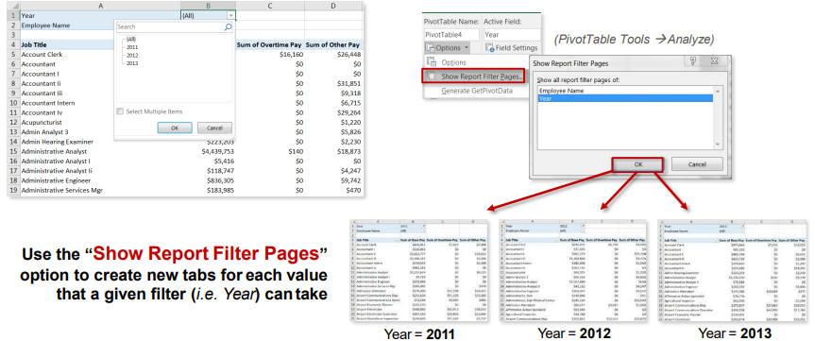

# Calculated values and Fields

## Summary Values By:

Summary Values by determines how numbers should be treated when they rolled up or aggregated (sum, count, average, max, etc.).

**Pro Tips:** Excel will default to ‘Count Of’ if a data column contains blanks or non-numerical values. Typically, you will want to change this field setting ‘Sum Of’.

## Show Values As – Examples:

Show Value As options allows you to apply additional calculations to change the way values are shown, such as the Percent of a Total or Subtotal, running value, rank, etc.

* In this case, we are showing Order Quantity values as % of Column Total, rather than whole numbers.
* Examples: We have normal value (no calculation), % of Total Column, % of Parent (genre), % Difference (Prev.year), Running Total (by year), Rank (Large -> Small).

## Show values as – Index:

The Index calculation uses an aggregated weighted average to reveal the impact of one number within the context of a data set.

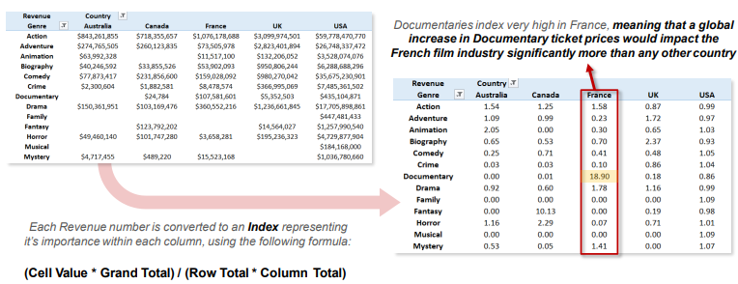

## Calculated Fields:

In the analyse tab, Calculated fields allow to create new measures based on existing, numerical fields:

**Pro tips:** Don’t calculate rate metrics (i.e. CTR, CPC) in your raw data, use calculated fields in your Pivot. This ensures that they calculate properly no matter how your data is rolled up.

## Calculating Using Counts:

Calculated fields are always based on the SUM of other fields (even if they are shown as a count, max, average, etc.). But what if you want to make a calculation based on the COUNT of a field?

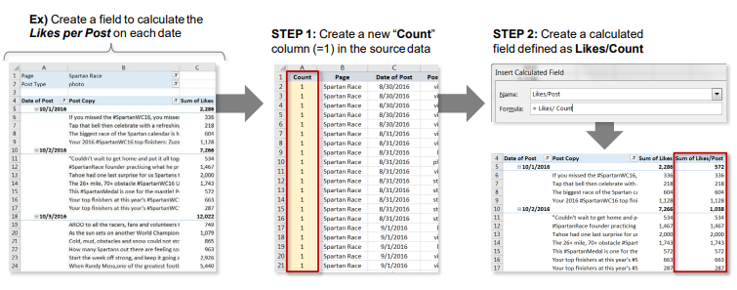

## Calculated Items:

Calculated items allow you to create new dimensions or categories based on existing dimensions:

**Pro tips:** don’t use calculated items unless you need to: you are usually better off simply grouping fields or adding new category columns within your source data itself.

## Solve Order:

In the Analyse Tab, in Fields, Items and Sets, there is solve order section.

If you have defined multiple calculated items, the Solve Order can be used to determine which calculations to prioritise (value is determined by the last formula in the list).

## List Formulas:

The **List Formulas** tool produces a new tab summarising all calculated fields and items associated with a given Pivot, along with the current solve order.

# Pivot Charts

## Pivot Chart 101

A PivotChart is simply a chart that is tied to a specific PivotTable; as you adjust filters and fields in your Pivot, the Pivot Chart updates dynamically.

1. Select your Pivot and choose PivotChart form either the “Insert” Tab or the “Analyse” Tab.
2. Select a chart type
3. The PivotChart will be inserted, and dynamically tied to the pivot (note: you can filter the view using either the pivot table or the chart itself).

## Pivot Chart options:

The “Analyse” Tab:

The “Design” Tab:

The “Format” Tab:

## Pivot Chart Layouts and Styles:

Chart Layouts and Styles allow you to adjust the look and feel of a PivotChart, including adding elements, changing colour palettes, or applying pre-set templates.



## Pivot Chart Field Buttons

We have Field buttons allow you to apply or adjust filters directly within the chart.

**Pro Tip:** You can format PivotCharts exactly like normal Excel Charts – the only difference is that PivotCharts are dynamically tied to a PivotTable.

## Adding Slicer:

A **Slicer** is basically a “prettier” version of a PivotTable filter; it works exactly the same way by filtering the data you see in your PivotTable and PivotCharts.

1. Select a PivotTable and choose “Insert Slicer” from the “PivotTable Tools” tab
2. Select the field(s) that you want to filter
3. The slicer will be insert next to your table, allowing you to filter on specific values (or combinations, using the CTRL key)

## Adding Timeline:

A Timeline works just like a slicer – its just formatted to work specifically with date and Time fields

1. Select your pivot Table and choose “Insert Timeline” from the “PivotTable Tools” tab
2. Select the date/time field (s) that you want to filter.
3. The Timeline is inserted, allowing you to filter on specific time frames (Note: may need to adjust unit of time (month, year, etc.)).